**Daily Onboarding challenge**

1. **1st day after signup**: On signup, the user will get challenges communication and 1st deposit offer

Notification sent to users about the rewards system

User will receive 1 Welcome spin: Rs 5

-> 24hr counter on each task

Rewards Max

* Bucket 1: Rs. 176
* Bucket 2: Rs. 356
* Bucket 3: Rs. 1412

Challenges are only applicable to mobile users only

Users will get spins while login on streak. 3 day streak login spin: sector will have deposit bonus and ticket. 5 day streak login spin: sector will have deposit bonus and ticket with high value. 10 day streak login spin: sector will have deposit bonus and cash reward

**Day 1**

We would be giving the user 2+1 Tasks in Day 1

|  |  |
| --- | --- |
| Task 1 | Convert bonus money to poker money |
| Task 2 | Register in any tournament |
| Task 3 | Play 10 hands |
| Reward | 5 + Ticket type 1 |

Streak Multiplier: Nil on Day 1

**Day 2**

We would be giving the user 2+1 Tasks in Day 2

|  |  |
| --- | --- |
| Task 1 | Deposit(For 1st deposit show offer) |
| Task 2 | Win 3 hands |
| Task 3 | Play 20 hands |
| Reward | 5 + Ticket type 2 |

Streak Multiplier:1.2

**Day 3**

We would be giving the user 2+1 Tasks in Day 3

|  |  |
| --- | --- |
| Task 1 | Which of the following below hand is a flush? A) As 8c 9c Ks 3s B) 7d 6d 5d Jh 10d c). 2d 5d 7d 9d jd |
| Task 2 | Play 30 hands |
| Task 3 | Play one cash tournament |
| Reward | 10 + Ticket type 3 |

Streak Multiplier:1.2

* **Initial Classification Starts**. 3 Buckets created with using data from user activity

|  |  |  |  |  |
| --- | --- | --- | --- | --- |
| Type of Data Points | Bucket 1  ( New user) | Bucket 2  (Middle user) | Bucket 3  (Experienced user) | |
| 3A | 3B |
| Deposits (X1) | 0 - 120 | 120 - 900 | >900 | |
| Total hands (X2) | 0 - 250 | 250 - 950 | >950 | |
| Cash wagering(X3) | 0 - 400 | 400 - 1200 | >1200 |  |
| Tournament spent(X4) | <12 | 12 - 500 | >500 | <50 |

Formula for Classification = < Weight based system (-1,1.25,+2)>

Total Score (TS)= 0.30 *X1 + 0.1 *X2 + 0.3*X3 + 0.3*X4

Bucket 1 = TS<-0.7

Bucket 2 = -0.7<=TS<0.4

Bucket 2 = TS>=0.4

3B: Total cash player(no tournament incentive for him)

If the total buyin in the first 3 days is less than Rs 50, the user from bucket 3 will be further put into bucket 3b(or based on buyin and cash wagering less than 0.1, both methods give similar results)

Based on the user data from last 6 months, the users were manually divided into 3 buckets based on the amount of cash put into the system. These initial buckets used the data from the whole user journey for 6 months and were divided based on a pre-decided proportion of users.

The data for these users in the first 3 days alone were passed through the above given bucketing system and the two results were compared.

71.43% of the users were correctly classified into their designated bucket

The average user starts playing games by 2 days from registration. As this value is not that large, the user’s tasks and timer will start as soon as he registers on the site.

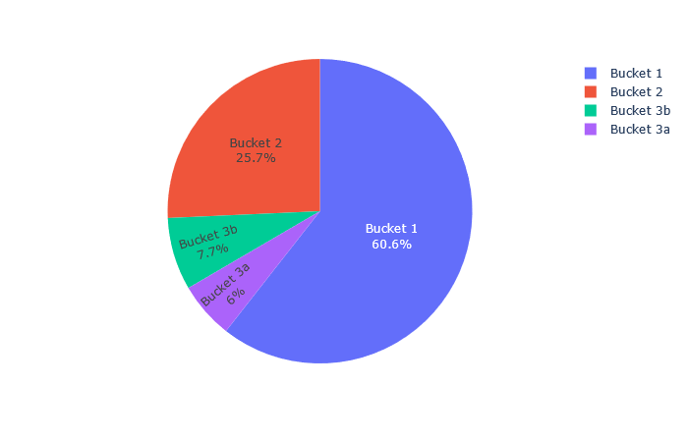

**Day 4**

We would be giving the user 2+1 Tasks in Day 1

|  |  |  |  |  |
| --- | --- | --- | --- | --- |
| Task | Bucket 1 | Bucket 2 | Bucket 3A | Bucket 3B |
| Deposit | Make a deposit | Make a deposit of min Rs 200 | Make a deposit of min Rs 1200 | Make a deposit of min Rs 1200 |
| Go all-in in a table | 1 time  (Any) | 1 time  (Any) | Cash table | Cash table |
| Play X tournament | 1 time  (Any) | 1 time  (Non-freeroll) | 3 time  (Non-freeroll) | Play 30 post-flop hands |
| Reward | 12 | 20 | 50 | 50 |

Streak Multiplier:1.2

**Day 5**

We would be giving the user 2+1 Tasks in Day 1

|  |  |  |  |  |
| --- | --- | --- | --- | --- |
| Task | Bucket 1 | Bucket 2 | Bucket 3A | Bucket 3B |
| Win x hands in a cash table | Min 3 | Min 15 | Min 50 | Min 50 |
|  | What are the total rewards you get when you refer a friend?  (A= 1100, B= 500, C= 2100) - Check here for answer -<https://www.9stacks.com/you/refer> | Win with a flush or higher combination on cash table | Win with a full house or higher combination on cash table | Win with a full house or higher combination on cash table |
|  | Play 10 post flop hands | Reach the final table in a tournament | Reach the final table in a tournament |  |
| Reward | 15 | 30+ ticket | 100 + ticket | 100 + ticket |

Streak Multiplier:1.2

**Day 6**

We would be giving the user 2+1 Tasks in Day 1

|  |  |  |  |  |
| --- | --- | --- | --- | --- |
| Tasks | Bucket 1 | Bucket 2 | Bucket 3A | Bucket 3B |
| Deposit | Make a deposit of min Rs 20 | Make a deposit of min Rs 400 | Make a deposit of min Rs 1500 | Make a deposit of min Rs 1500 |
|  | Play min 10 hands of PLO game | Play min 50 hands of cash PLO game | Get a black card made | Get a black card made |
|  | Win a hand in cash table with a Flush and above combination | Win 1 hand showdown with 3 or more players | Win 5 hands showdown with 3 or more players | Win 5 hands showdown with 3 or more players |
| Reward | 15 | 30 | 120 | 120 |

Streak Multiplier:1.2

**Day 7**

We would be giving the user 2+1 Tasks in Day 1

|  |  |  |  |  |
| --- | --- | --- | --- | --- |
| Tasks | Bucket 1 | Bucket 2 | Bucket 3A | Bucket 3B |
|  | Name the contest running in Rs.2/Rs.4 tables.  A)Genie B)Hit&Win C)Kick-Back | Play Normal tournament with Buyin Rs. 50 & above | Play Normal* tournament with Buyin Rs. 500&above |  |
| Play min 20 hands of cash game with minimum bb X | 1BB - 2BB | 5BB - 10BB | 20BB+ | 20BB+ |
|  | Play a timed tournament | Play 3 Preflop 3- bet  Hands on cash table | Play 10 Preflop 3- bet  Hands on cash table | Play 10 Preflop 3- bet  Hands on cash table |
| Reward | 18 | 40 + ticket | 150 + ticket | 150 + ticket |

Streak Multiplier:1.2

**Day 8**

We would be giving the user 2+1 Tasks in Day 1

|  |  |  |  |  |
| --- | --- | --- | --- | --- |
| Tasks | Bucket 1 | Bucket 2 | Bucket 3A | Bucket 3B |
|  | Play tournament with minimum buyin Rs 50 | Win with pocket 9 | Win with pocket 9 on omaha table | Win with pocket 9 on omaha table |
| Win min X hands of Cash games | 10 | 30 | 50 | 50 |
| Deposit | Min 100 | Min 600 | Min 2500 | Min 2500 |
| Reward | 18 | 40 | 200 | 200 |

Streak Multiplier:1.2

**Day 9**

We would be giving the user 2+1 Tasks in Day 1

|  |  |  |  |  |
| --- | --- | --- | --- | --- |
| Tasks | Bucket 1 | Bucket 2 | Bucket 3A | Bucket 3B |
|  | What is your referral code? - 3 options (A,B,C) | Play 75 hands of cash Omaha or PLO game | Hit flush of all 4 suits in a day | Hit flush of all 4 suits in a day on cash table |
|  | Win 3 hands in a row | Participate in santa contest | Participate in karan arjun contest | Participate in karan arjun contest |
| Play time crunch tournament with min buyin Rs X | 50 | 250 | Buy and redeem a tournament ticket |  |
| Reward | 20 | 50 + ticket | 250 + ticket | 250 + ticket |

Streak Multiplier:1.2

**Day 10**

We would be giving the user 2+1 Tasks in Day 1

|  |  |  |  |  |
| --- | --- | --- | --- | --- |
| Tasks | Bucket 1 | Bucket 2 | Bucket 3B | Bucket 3B |
| Refer a friend | 1 Referral | 1 Referral | 1 Referral | 1 Referral |
| Deposit | Min 150 | Min 1000 | Min 4000 | Min 4000 |
|  | 1 StackUp Point = Rs. _____ of Rake. Clue: Check this link for the answer <https://www.9stacks.com/with/loyalty> | - | - | - |
| Reward | 20 | 50 | 250 | 250 |

Streak Multiplier: 1.2